HOTEL MANAGEMENT SYSTEM

A MINI PROJECT REPORT

[CASE STUDY]

Submitted by

Ved Tusharbhai Patel [RA2211003010609]

Shreyan Sarkar [RA2211003010771]

Under the Guidance of

Dr. Rajalakshmi M
[Assistant Professor, Department of Computing Technologies]



DEPARTMENT OF COMPUTING TECHNOLOGIES FACULTY OF ENGINEERING AND TECHNOLOGY SRM INSTITUTE OF SCIENCE AND TECHNOLOGY KATTANKULATHUR– 603 203

NOV 2024

i

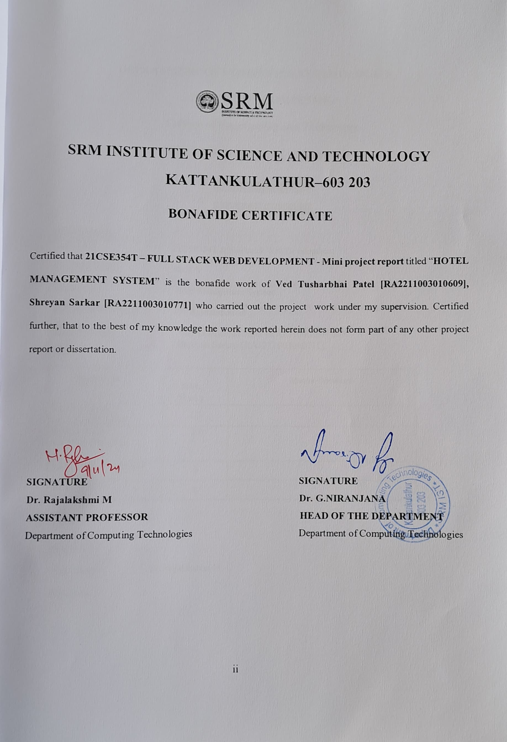

DEPARTMENT OF COMPUTING TECHNOLOGIES SCHOOL OF COMPUTING
College of Engineering and Technology SRM Institute of Science and Technology

MINI PROJECT REPORT

ODD Semester, 2024-2025

Subject code &
\Sub Name : 21CSE354T & Full stack Web Development

Year & Semester : III & V

Project Title : Hotel Management System

Course Faculty Name : Dr. Rajalakshmi M

Team Members : Ved Tusharbhai Patel [RA2211003010609]
Shreyan Sarkar [RA2211003010771]

Particulars | Max. Marks | Marks Obtained
FRONT END  DEVELOPMENT | 2.5
BACK END DEVELOPMENT | 2.5
IMPLEMENTATION | 3
REPORT | 2

Date :

Staff Name : Dr. Rajalakshmi M

Signature :

iii

ACKNOWLEDGEMENT

We express our humble gratitude to Dr C. Muthamizhchelvan, Vice-Chancellor, SRM Institute of Science and Technology, for the facilities extended for the project work and his continued support. We extend our sincere thanks to Dean-CET, SRM Institute of Science and Technology, Dr T.V.Gopal, for his invaluable support.

We wish to thank Dr Revathi Venkataraman, Professor and Chairperson, School of Computing and Dr M. Pushpalatha, Associate chairperson, Department of Computing Technologies, SRM Institute of Science and Technology for their invaluable support.

We are grateful to our Head of the Department, Dr G. Niranjana, Professor, Dept of CTECH, SRMIST, for her suggestions and encouragement at all the stages of the project work.

We want to convey our thanks to our Audit Professor, Dr R. K Pongiannan, Professor, Department of Computing Technologies, SRM Institute of Science and Technology, for their inputs during the project reviews and support.

Our inexpressible respect and thanks to our course faculty, Dr. Rajalakshmi M, Assistant Professor, Department of CTECH, SRMIST, for providing us with an opportunity to pursue our project under her mentorship. She provided us with the freedom and support to explore the research topics of our interest. Her passion for solving problems and making a difference in the world has always been inspiring.

Ved Tusharbhai Patel [RA2211003010609]

Shreyan Sarkar [RA2211003010771]

iv

TABLE OF CONTENTS

ABSTRACT 1
1. | INTRODUCTION 2  1.1 Overview of the Hotel Management System
2 | - Front-End Development with React: Enhancing User Interaction  - Back-End Architecture with Spring Boot and MySQL: Ensuring Data Security and Scalability  PROJECT OVERVIEW AND OBJECTIVES 6
 | 2.1 | Objectives
3 | ARCHITECTURE DIAGRAM AND TECHNOLOGIES USED 7
 | 3.1 | Architecture Diagram
 | 3.2 | Frontend Design
 | 3.3 | Backend Design
4 | PROJECT PLANNING 10
 | 4.1 | Requirements
 | 4.2 | Database Design
5 | FRONTEND DEVELOPMENT 15
 | 5.1 | HTML/CSS Structure
 | 5.2 | JavaScript and Frontend Frameworks (React JS)
6 | BACKEND DEVELOPMENT 19
 | 6.1 | API Design, Authentication, and Database Connectivity
 | 6.2 | Database Management – Spring boot Concepts and CRUD Operations
7 | TESTING AND DEPLOYMENT 22
8. | RESULTS AND CONCLUSION 24  8.1 Conclusion
8.2 Future Scope

REFERENCES
APPENDIX 1 - CODE APPENDIX 2

v

ABSTRACT

The Hotel Management System project is a full-stack application designed to streamline and digitize hotel management operations, providing an intuitive and efficient interface for both administrators and customers. This system comprises a front-end built with React and a back- end developed using Spring Boot, creating a cohesive environment that offers seamless interaction and real-time data synchronization. The front-end, developed in React, provides a user-friendly interface that enables customers to browse hotel services, make reservations, and manage their bookings. Core components such as the booking form, services display, and navigation options are designed for ease of use and accessibility, enhancing the user experience. By leveraging Axios for HTTP requests, the front-end effectively communicates with the back- end, enabling real-time booking updates and responses. The back-end, powered by Spring Boot, handles data processing, storage, and management. Using MySQL as the database, it ensures secure storage of booking details and customer information, implementing essential CRUD (Create, Read, Update, Delete) operations for efficient data handling. The Spring Data JPA and MySQL integration facilitate seamless data interactions, while RESTful APIs allow the front- end to send booking requests and retrieve data. Key back-end features include secure user data handling, robust booking management, and scalability to accommodate additional functionalities. The Hotel Management System enables hotel administrators to manage reservations, monitor room availability, and update hotel offerings from a centralized location, reducing manual processes and operational bottlenecks. The platform’s modular design also supports future expansion, such as adding features like payment gateways, user authentication, and real-time notifications. This project demonstrates the effective use of modern web development frameworks, creating a reliable and scalable solution for hotel management. It is a versatile platform that meets both customer and administrative needs, offering a comprehensive solution for the hospitality sector’s evolving digital landscape.
1

INTRODUCTION

Overview of the Hotel Management System Project

The Hotel Management System (HMS) project is a comprehensive, full-stack solution aimed at transforming the way hotels manage bookings, guest services, and day-to-day operations. This project integrates a user-friendly front end, developed in React, with a powerful back end built on Spring Boot and MySQL. Together, these technologies create a seamless and cohesive platform that addresses the diverse needs of both hotel staff and customers. The system allows guests to easily explore hotel services, make reservations, and manage their bookings online. For hotel administrators, it provides tools to monitor room availability, handle guest requests, and make timely updates to the hotel's service offerings. This not only simplifies internal processes but also elevates the customer experience by ensuring that guests have access to reliable and timely information.

One of the HMS project’s primary goals is to automate and streamline hotel management tasks that are often handled manually. This digital transformation reduces human error and minimizes the time and resources spent on tasks such as recording bookings, confirming reservations, and updating room availability. Additionally, the system’s modular design allows hotels to customize and expand functionalities to meet specific operational needs.

With features like real-time data updates, secure storage of guest information, and efficient booking management, the HMS project addresses both functional and security requirements critical in today’s hospitality sector. For instance, MySQL provides a secure environment for storing sensitive data, while Spring Boot facilitates efficient data processing and API management. The HMS project serves as a scalable and adaptable solution that can grow with the hotel’s needs, making it a valuable tool for hotels seeking a competitive edge in an increasingly digital landscape. By modernizing hotel operations, this system promotes improved service quality, operational efficiency, and customer satisfaction, ultimately benefiting both the hotel management team and their guests.

By leveraging modern web technologies and frameworks, the system not only addresses the current challenges faced by hotel management but also anticipates future demands. The modular design allows for the easy integration of additional features, such as payment processing, user authentication, and enhanced analytics for monitoring booking trends and customer behavior. This flexibility ensures that the system can evolve alongside advancements in technology and changes in customer expectations, making it a future-proof solution for hotels aiming to stay competitive in a rapidly changing market.
2

Front-End Development with React: Enhancing User Interaction

In developing the Hotel Management System, a front-end built with React greatly enhances user interaction by providing a smooth, responsive interface that prioritizes accessibility and ease of use. React’s component-based architecture enables efficient reusability, allowing for a well- organized structure that can adapt as the project scales. With features such as the booking form and navigation menu, the system offers users an intuitive experience for tasks like room reservation, service browsing, and checking booking status.

React’s declarative approach simplifies state management, ensuring that any changes to the data reflect instantly on the interface, creating a seamless, dynamic experience. For instance, when a user inputs booking details, React’s state updates manage and track this data in real-time, making interactions like date selections or name inputs feel smooth. By using React hooks such as useState and useEffect, the application efficiently manages data, enabling actions like form submissions and response handling without needing page reloads.

In this project, the Axios library facilitates communication between the front end and back end, handling API requests smoothly to ensure data synchronization across the application. When a user submits a booking request, Axios sends the data to the back end, which processes it and returns a response, providing feedback to the user promptly. This integration allows for real-time updates, enhancing the reliability and responsiveness of the application.

By structuring the interface for clarity and speed, the React-based front end not only enriches the user experience but also supports future scalability. Additional features, like integrating a calendar for booking dates or a gallery to display room options, can be implemented with ease due to React’s modular nature. Ultimately, React’s capabilities create a highly interactive, efficient, and visually appealing front end that meets the needs of both customers and administrators.
3

Moreover, implementing accessibility best practices in the React application ensures that all users, including those with disabilities, can navigate and interact with the system effectively. This involves incorporating ARIA (Accessible Rich Internet Applications) attributes, semantic HTML, and keyboard navigation support, allowing users with assistive technologies to access the booking features without barriers. By focusing on inclusivity, the Hotel Management System not only adheres to legal standards but also broadens its reach, allowing a more diverse audience to utilize its services. This commitment to accessibility is not only a moral imperative but also a business advantage, as it demonstrates a hotel’s dedication to providing exceptional service to all guests, fostering a positive reputation in a competitive market.

In conclusion, the front-end development with React in the Hotel Management System plays a crucial role in enhancing user interaction, establishing a robust foundation for a responsive and engaging experience. With its component-based architecture, seamless data handling through Axios, and emphasis on design and accessibility, the system is poised to meet the needs of both customers and hotel administrators effectively. As the project evolves, React’s modularity will allow for further enhancements and feature additions, ensuring that the Hotel Management System remains competitive and aligned with industry standards, ultimately driving guest satisfaction and operational efficiency.
4

Back-End Architecture with Spring Boot and MySQL: Ensuring Data Security and Scalability

The back-end architecture of the Hotel Management System is built on Spring Boot, a powerful framework that simplifies the development of Java applications by providing a set of pre-configured features. Spring Boot's dependency injection and convention-over-configuration principles enable developers to create robust and scalable applications quickly. By leveraging Spring Boot, we can easily set up RESTful APIs to handle various operations such as creating, reading, updating, and deleting booking information. This architecture allows for modular design, ensuring that each component can be developed, tested, and maintained independently, thus enhancing the overall development process.

Data security is a paramount concern in any application dealing with user information and transactions. To safeguard sensitive data, the Hotel Management System employs several security measures, including secure database connections, user authentication, and proper data validation. Spring Boot provides built-in security features, such as Spring Security, which can be integrated to handle user authentication and authorization effectively. By implementing role-based access controls, the system ensures that only authorized users can access or modify specific resources, significantly reducing the risk of data breaches and unauthorized access.

In this architecture, MySQL serves as the relational database management system, providing a robust and reliable data storage solution. The choice of MySQL allows for efficient querying and transaction management, which is crucial for a hotel management system that handles multiple concurrent requests. Using Spring Data JPA, the application can easily map Java objects to database tables, enabling seamless data manipulation and retrieval. Moreover, MySQL’s support for ACID properties ensures that the transactions remain consistent and reliable, even under high load, contributing to the overall stability of the application.

Scalability is another essential aspect of the back-end architecture. The modular design of Spring Boot applications allows for easy scaling as demand increases. The architecture supports horizontal scaling, where additional instances of the application can be deployed to handle increased loads. Additionally, using load balancers can distribute incoming requests across multiple instances, ensuring that no single server becomes a bottleneck. By combining these scaling techniques with a robust database like MySQL, the Hotel Management System can accommodate a growing user base without sacrificing performance.
5

2. PROJECT OVERVIEW AND OBJECTIVES

The objective of the Hotel Management System project is to create an integrated, user-friendly platform that enhances the efficiency of hotel management operations while providing a seamless experience for both customers and administrators. In an era where digital solutions are paramount, this project aims to digitize traditional hotel management processes, allowing for real-time data access, improved communication, and streamlined workflows. One of the primary objectives is to develop a robust front-end interface using React, which facilitates easy navigation and interaction for users. The interface will be designed to showcase hotel services, provide booking functionalities, and offer management features, ensuring that users can effortlessly access information and complete transactions. By incorporating modern design principles and responsive layouts, the application will cater to a diverse user base, including tech-savvy customers and those less familiar with digital tools.

Another key objective is to establish a powerful back-end system using Spring Boot, which will handle all data processing, storage, and security aspects of the application. This back-end architecture aims to provide a secure and efficient environment for managing sensitive customer information and booking data. The system will leverage MySQL as the database management solution. The architecture will support essential functionalities such as creating, updating, and managing bookings, as well as handling user authentication and authorization. By implementing robust security measures, including encrypted data storage and secure API endpoints.

Additionally, the project seeks to enhance operational efficiency for hotel administrators. With centralized management capabilities, administrators will be able to monitor room availability, manage bookings, and update services and rates through a single interface. This objective focuses on reducing manual processes and minimizing operational bottlenecks, ultimately improving overall productivity and customer satisfaction. By offering features such as real-time notifications for booking changes and cancellations, the system ensures that hotel staff can respond promptly to customer needs, fostering a positive experience.

The Hotel Management System also aims to provide analytics and reporting features that offer insights into booking trends, customer preferences, and overall business performance. These analytics will enable hotel managers to make informed decisions regarding pricing strategies, promotional campaigns, and service enhancements. By analyzing data on customer demographics and booking patterns, the system can help identify opportunities for growth and improvement, allowing hotel management to tailor their offerings to better meet the needs of their clientele.
6

3.ARCHITECTURE DIAGRAM AND TECHNOLOGIES USED

3.1 Architecture Diagram

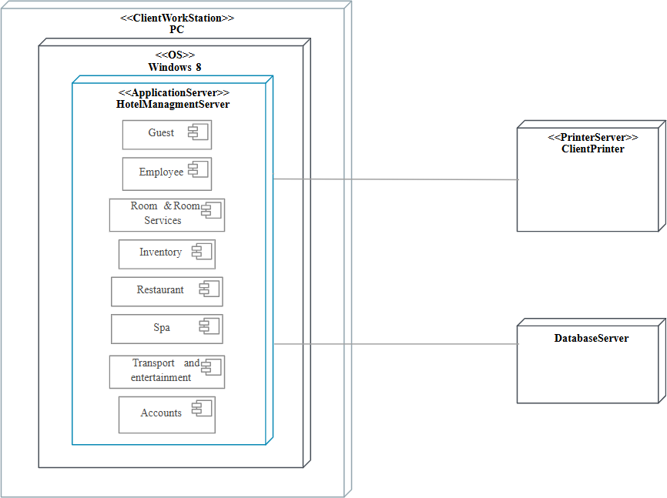

This Hotel Management System architecture consists of a Client Workstation, an Application Server, a Printer Server, and a Database Server. The Client Workstation, typically a PC, provides hotel staff with a user interface to access various services, such as guest check-ins and check-outs, employee management, room and restaurant services, and accounts. The Application Server is the core of the system, managing different hotel functions through separate modules, each dedicated to a specific service, ensuring organized and efficient handling of hotel operations.

The Printer Server is responsible for enabling the printing of essential documents like invoices, receipts, and reports directly from the Client Workstation, making it easy for staff to access printed materials when needed. The Database Server serves as the central storage unit, housing all critical data related to guests, employees, room availability, financial transactions, and inventory.

Through seamless communication between the Client Workstation, Application Server, and Database Server, this architecture promotes efficient workflows and secure data handling.
7

Frontend Design

The frontend design of the Hotel Management System leverages modern technologies and frameworks to create an intuitive and responsive user interface that enhances the overall user experience. Here are the primary technologies utilized in the frontend development:

- React: React is the cornerstone of the frontend architecture. It is a JavaScript library for building user interfaces, particularly suited for single-page applications (SPAs). React's component-based architecture allows developers to create reusable UI components, making the development process more efficient and organized. The use of a virtual DOM improves performance by minimizing direct interactions with the actual DOM, resulting in faster rendering and a smoother user experience.
- React Router: To facilitate navigation within the application, React Router is employed. This library enables the implementation of dynamic routing, allowing users to navigate between different views and components without reloading the entire page. React Router enhances the SPA experience, ensuring that transitions are seamless and responsive.
- Axios: For making HTTP requests to the backend server, Axios is utilized. This promise-based HTTP client simplifies the process of sending asynchronous requests, handling responses, and managing errors. Axios allows for easy integration with RESTful APIs, enabling the frontend to communicate effectively with the Spring Boot backend for data retrieval and manipulation.
- Bootstrap: To ensure a visually appealing and responsive design, Bootstrap is integrated into the project. This popular CSS framework provides a set of pre-designed components and a grid system, enabling developers to create layouts that adapt to various screen sizes. Bootstrap's responsive design capabilities ensure that users have a consistent experience across devices, from desktops to smartphones.
- JavaScript (ES6+): Modern JavaScript features, such as ES6 syntax, are employed throughout the frontend code. This includes features like arrow functions, template literals, destructuring, and modules, which enhance code readability and maintainability. Leveraging ES6 allows developers to write cleaner and more efficient code, streamlining the development process.
- CSS Preprocessors (e.g., SASS or LESS): For more advanced styling capabilities, a CSS preprocessor like SASS or LESS may be used. These preprocessors allow developers to write modular CSS, utilize variables, and create nested styles, improving the organization of stylesheets and enabling more complex design implementations.
8

Backend Design

The backend design of the Hotel Management System is built upon robust technologies and frameworks that ensure data security, scalability, and efficient processing. Here are the key technologies utilized in the backend development:

- Spring Boot: At the heart of the backend architecture is Spring Boot, a framework designed to simplify the development of Java applications. Spring Boot provides a variety of features, including auto-configuration, embedded servers, and production-ready settings. Its emphasis on convention over configuration allows developers to focus on building business logic rather than boilerplate code, making the development process faster and more efficient.

- Spring Data JPA: To facilitate data access and persistence, Spring Data JPA is integrated into the backend. This framework simplifies database interactions by providing a repository abstraction layer, allowing developers to define database operations without writing complex SQL queries. It streamlines CRUD (Create, Read, Update, Delete) operations and integrates seamlessly with Spring Boot, ensuring that data can be managed efficiently.

- MySQL: MySQL is the chosen relational database management system (RDBMS) for storing and managing hotel data, including customer information, reservations, and room availability. MySQL's robustness, support for complex queries, and reliability make it an ideal choice for applications that require data integrity and scalability.

- Spring Security: To safeguard sensitive data and ensure secure user authentication and authorization, Spring Security is implemented. This powerful framework provides comprehensive security features, including role-based access control, password encryption, and session management, protecting user data and maintaining compliance with security standards.

- Hibernate: As an ORM (Object-Relational Mapping) tool, Hibernate is often used alongside Spring Data JPA to simplify database interactions. Hibernate allows developers to map Java objects to database tables, enabling easy retrieval and manipulation of data. Its caching capabilities and support for lazy loading further enhance the application's performance and scalability.

6Maven: For dependency management and build automation, Maven is employed in the backend development. Maven simplifies the management of project dependencies and provides a standardized build process, allowing developers to focus on writing code while ensuring that the project is well-structured and maintainable.
9

4. PROJECT PLANNING

Requirements

The success of the Hotel Management System project hinges on a well-defined set of requirements that encompasses both functional and non-functional aspects. These requirements will serve as a foundation for the development process, guiding the design, implementation, and testing phases to ensure that the system meets the needs of its users, including hotel administrators and customers.

Functional Requirements:

- User Registration and Authentication:

  - The system must allow users to create accounts and log in to access their profiles and booking information.
  - Admins should have separate login credentials to manage the hotel’s operations.

- Room and Service Management:

  - Admin users should be able to add, edit, and delete room details, including room types, availability, and pricing.
  - The system must allow administrators to manage various hotel services such as dining options, spa services, and special offers.

- Booking Management:

  - Users should be able to search for available rooms based on their preferred dates and room types.
  - The system must allow users to make reservations, modify existing bookings, and cancel reservations.
  - Users should receive confirmation notifications upon successful booking.

- Payment Processing:

  - The application should support secure online payment options for customers during the booking process.
  - Admins should be able to view and manage payment transactions and generate financial reports.
10

- Customer Reviews and Feedback:

  - Users should be able to leave reviews and ratings for their stay, which can be viewed by other potential customers.
  - Admins should have the ability to manage and respond to customer feedback.

Non-Functional Requirements:

- Performance:

  - The system must handle a large number of simultaneous users without significant performance degradation.
  - Response times for user requests, such as room availability checks and booking confirmations, should be minimized.

- Security:

  - User data must be securely stored, and sensitive information (e.g., passwords, payment details) must be encrypted.
  - The system should implement role-based access controls to ensure that users can only access features relevant to their roles.

- Usability:

  - The interface must be intuitive and user-friendly, providing a seamless experience for users of varying technical expertise.
  - The design should be responsive, ensuring compatibility across different devices and screen sizes.

- Scalability:

  - The architecture should support future growth, allowing for the addition of new features and services without major system overhauls.
  - The system must be designed to accommodate an increasing number of users and transactions as the hotel business expands.
11

Database Design

The database design for the Hotel Management System is crucial for ensuring efficient data storage, retrieval, and management. A well-structured database schema will support the system's functional and non-functional requirements, enabling seamless interactions between the frontend and backend. The database will primarily utilize MySQL, a relational database management system, to manage hotel-related data effectively. Below is an overview of the key entities, their attributes, and the relationships between them.

Entities and Attributes:

- User:

  - user_id (Primary Key): Unique identifier for each user.
  - username: The name chosen by the user for login.
  - password: The hashed password for secure authentication.
  - email: User's email address for communication and notifications.
  - role: Defines the user’s role (e.g., customer, admin).

Room:

  - room_id (Primary Key): Unique identifier for each room.
  - room_number: The specific number or identifier of the room.
  - room_type: Type of room (e.g., single, double, suite).
  - availability: Status indicating if the room is available for booking.
  - price: The cost per night for the room.

Booking:

  - booking_id (Primary Key): Unique identifier for each booking.
  - user_id (Foreign Key): References the user making the booking.
  - room_id (Foreign Key): References the room being booked.
  - start_date: The date when the booking starts.
  - end_date: The date when the booking ends.
  - status: The status of the booking (e.g., confirmed, canceled).
12

Service:

  - service_id (Primary Key): Unique identifier for each service.
  - service_name: The name of the service (e.g., spa, restaurant).
  - description: A brief description of the service.
  - price: The cost associated with the service.

Payment:

  - payment_id (Primary Key): Unique identifier for each payment transaction.
  - booking_id (Foreign Key): References the related booking.
  - amount: The total amount paid.
  - payment_date: The date when the payment was made.
  - payment_method: The method used for payment (e.g., credit card, PayPal).

Review:

  - review_id (Primary Key): Unique identifier for each review.
  - user_id (Foreign Key): References the user who submitted the review.
  - room_id (Foreign Key): References the room being reviewed.
  - rating: The rating given by the user (e.g., 1 to 5 stars).
  - comment: A text field for the user to provide feedback.

Relationships:

- User and Booking:

  - A user can have multiple bookings, establishing a one-to-many relationship between the User and Booking entities.

Room and Booking:

  - A room can be booked multiple times, but each booking references a single room, establishing a one-to- many relationship between Room and Booking entities.
13

Booking and Payment:

  - Each booking may have one corresponding payment transaction, creating a one-to-one relationship between Booking and Payment entities.

User and Review:

  - A user can submit multiple reviews, establishing a one-to-many relationship between User and Review entities.

Room and Review:

  - A room can have multiple reviews, creating a one-to-many relationship between Room and Review entities.

Schema Diagram: The database schema diagram would visually represent the entities and their relationships, providing a clear overview of how data flows within the Hotel Management System. Each entity would be represented as a table with its attributes listed, and lines would indicate the relationships between the tables.

This database design aims to ensure data integrity, reduce redundancy, and provide efficient data access for the Hotel Management System, ultimately contributing to a seamless user experience.
14

  - HTML/CSS Structure

FRONTEND DEVELOPMENT

The HTML and CSS structure of the Hotel Management System forms the foundation of the user interface, ensuring a visually appealing and functional design that facilitates user interaction. A well-organized HTML structure not only enhances usability but also improves accessibility and search engine optimization (SEO). The following sections detail the key components of the HTML/CSS structure used in the project.

The HTML structure is organized into distinct sections that correspond to the different functionalities of the hotel management system. This modular approach allows for easy maintenance and scalability as new features can be integrated seamlessly. The core components of the HTML structure include:

  - The header section includes the hotel logo, a navigation bar with links to different pages (e.g., Home, Booking, Services, Contact), and any promotional banners. Using the header tag ensures that this vital information is easily recognizable by search engines and screen readers, enhancing both SEO and accessibility. The navigation links are crafted with a tags, enabling easy access to different areas of the application.

  - This section is subdivided into multiple areas, each dedicated to specific functionalities. For instance, the main content area includes sections for room listings, booking forms, customer reviews, and special offers. Semantic HTML tags such as section, article, and aside are employed to differentiate these content areas, making the structure more intuitive and readable.

  - For user interactions such as booking rooms or submitting inquiries, forms are implemented using the form tag. Input fields for name, email, phone number, dates of stay, and other relevant information are created with input, select, and textarea elements. Each form element is accompanied by descriptive labels, ensuring that users can easily understand the information required.

  - The footer section contains links to privacy policies, terms of service, contact information, and social media icons. By using the footer tag, this information is structured to provide essential details without cluttering the main content. It serves as a comprehensive reference point for users seeking additional information about the hotel or its policies.

The CSS styling is carefully crafted to ensure that the application is not only visually appealing but also responsive across various devices. The following key techniques are employed:
15

- CSS Flexbox and Grid layouts are utilized to create flexible and responsive designs that adjust seamlessly to different screen sizes. For instance, the room listings may use a grid layout to display images and details side by side on larger screens while stacking them vertically on mobile devices.

- Media queries are implemented to adapt styles based on screen width, allowing the layout to change dynamically. For example, font sizes, button sizes, and padding can be adjusted for better usability on smaller devices, ensuring that all users have a pleasant experience regardless of their device type.

3.A consistent design language is established using a unified color palette, typography, and spacing conventions. By defining CSS variables for colors and font sizes, the design can be easily maintained and updated. This consistency not only enhances the aesthetic appeal but also reinforces the brand identity of the hotel.

- Accessibility is a crucial aspect of the frontend design. Semantic HTML is combined with ARIA (Accessible Rich Internet Applications) attributes to ensure that the application is navigable for users with disabilities. Contrast ratios are checked to ensure readability, and alt attributes are provided for all images to aid visually impaired users.

- CSS animations and transitions are employed to enhance user interactions. For example, buttons may have hover effects that change color or size, providing visual feedback that improves the overall user experience. Such subtle enhancements contribute to a modern and engaging interface.

By carefully structuring the HTML and applying thoughtful CSS styling, the Hotel Management System achieves a design that is both functional and aesthetically pleasing. This foundational work sets the stage for further development and integration of dynamic features that will enhance the overall user experience.
16

JavaScript and Frontend Frameworks (React JS)

The integration of JavaScript, particularly through the React framework, is pivotal for building a dynamic and responsive frontend for the Hotel Management System. React's component-based architecture allows developers to create reusable UI components, facilitating efficient development and easy maintenance. This section delves into the role of JavaScript and React in enhancing user interactions and overall application functionality.

React's component-based architecture is one of its most significant advantages. Each component encapsulates its own logic and rendering, enabling developers to build complex user interfaces by composing smaller, self- contained pieces. In the Hotel Management System, components such as the booking form, room listings, navigation bar, and user testimonials are implemented as independent units. This modular approach not only promotes code reusability but also simplifies debugging and testing processes. For instance, if an issue arises within the booking form component, developers can address it without affecting the rest of the application.

In React, state management is crucial for creating interactive applications. The component state allows for dynamic updates to the UI based on user interactions. For example, when a user fills out the booking form, the component state is updated with the input values. This state management ensures that the user interface reflects the most current data without requiring a page reload. Additionally, React's use of the Virtual DOM optimizes rendering performance by minimizing direct manipulation of the actual DOM, resulting in a smoother user experience.

To enable real-time data exchange between the frontend and backend, Axios is integrated into the React application. Axios is a promise-based HTTP client that simplifies making requests to RESTful APIs. In the Hotel Management System, Axios is used to fetch data such as available rooms, special offers, and user reviews, as well as to submit booking requests to the backend. This integration ensures that users have access to up-to-date information, enhancing their ability to make informed decisions during the booking process.

React Router is employed to manage navigation within the application, allowing for a seamless user experience. With React Router, the application can maintain a single-page application (SPA) architecture, where users can navigate between different views without experiencing full page reloads. This is particularly beneficial for a hotel management system, as users may frequently switch between viewing room details, booking forms, and service offerings. By defining routes for each component, React Router facilitates a smooth and intuitive navigation experience, enhancing user satisfaction.
17

JavaScript and React provide several features that significantly enhance user experience. For instance, form validations can be implemented to ensure that users enter the required information correctly before submission. Instant feedback can be provided for input fields, such as showing error messages or success notifications based on user actions. Additionally, animations can be incorporated using libraries like React Spring to add visual flair to transitions and interactions, making the application feel modern and engaging.

In summary, the combination of JavaScript and the React framework enables the Hotel Management System to offer a rich and interactive user experience. By leveraging component-based architecture, state management, API integration, routing, and enhanced user interaction features, the frontend is designed to meet the needs of both customers and hotel administrators effectively. This modern approach not only improves usability but also lays the groundwork for future enhancements and scalability within the application.
18

- BACKEND DEVELOPEMENT

  - API Design, Authentication, and Database Connectivity

The Hotel Management System leverages a well-structured API design to facilitate smooth interactions between the frontend and backend components of the application. The application adheres to RESTful principles, which promote stateless communication and resource-oriented architecture. Each API endpoint is meticulously designed to handle specific operations related to hotel management, such as room bookings, customer management, and service inquiries. For instance, endpoints like /api/bookings handle all booking-related functionalities, while
/api/rooms manages room availability and details. This separation of concerns not only simplifies the design but also enhances the maintainability of the application.

The API endpoints utilize HTTP methods (GET, POST, PUT, DELETE) to perform CRUD operations on resources. For example, a GET request to /api/rooms retrieves a list of available rooms, while a POST request to
/api/bookings creates a new booking entry in the database. This clear mapping between HTTP methods and operations allows frontend developers to intuitively understand how to interact with the backend. Additionally, to ensure a user-friendly experience, the API provides meaningful response messages and status codes, making it easier to debug and handle errors.

Authentication plays a crucial role in securing the application, especially when sensitive user data is involved. The Hotel Management System implements JSON Web Token (JWT) for authentication purposes. Upon successful login, a JWT is generated and returned to the client. This token encodes user information and is signed to prevent tampering. For every subsequent request that requires authentication, the token is sent in the headers, allowing the server to validate the user's identity. This approach ensures that only authorized users can access certain endpoints, such as creating or modifying bookings.

Database connectivity is another key aspect of backend development. The Hotel Management System uses Spring Boot as its primary framework, which integrates seamlessly with MySQL as the chosen database management system. Spring Boot’s auto-configuration features significantly reduce the setup complexity, allowing developers to focus on implementing business logic rather than configuration details. The connection between the application and the MySQL database is defined in the application.Properties file, where developers specify parameters like the database URL, username, and password.

Moreover, Spring Data JPA is utilized to simplify database interactions. By creating entity classes that represent database tables, developers can map Java objects to records in the database effortlessly.
19

6.2 Database Management – Spring Boot Concepts and CRUD Operation

In the Hotel Management System, database management is critical for ensuring that data is stored, retrieved, and manipulated efficiently and reliably. By using Spring Boot, developers can take advantage of various concepts that simplify database interactions and enhance application performance. The database serves as the backbone of the application, storing essential information such as room details, customer bookings, and user accounts. The design of the database schema is carefully considered to reflect the relationships and constraints inherent in hotel management.

Spring Data JPA is a key component of the backend architecture, facilitating seamless communication between the Spring Boot application and the MySQL database. By defining entity classes for each table in the database, developers can create a domain model that represents the application’s data. For example, a Room entity may include attributes like room number, type, price, and availability status, which directly correspond to the columns in the rooms table. JPA annotations, such as @Entity and @Table, are used to specify how these classes map to the underlying database structures, enabling a clear and intuitive relationship between the code and the database.

CRUD operations form the foundation of any database management system, and Spring Boot simplifies their implementation through the use of repository interfaces. By extending the JpaRepository interface, developers gain access to a wide range of built-in methods that facilitate CRUD operations without the need for verbose code. For instance, the save() method allows for both creating new records and updating existing ones, while the findAll() and findById() methods enable easy retrieval of records. This functionality significantly reduces the amount of boilerplate code required, allowing developers to focus on implementing business logic rather than handling database operations manually.

Transaction management is another vital aspect of database management within the Hotel Management System. In scenarios where multiple database operations need to be executed as a single unit, Spring Boot provides robust transaction management capabilities. By annotating service methods with @Transactional, developers can ensure that all operations within that method are executed atomically. If any operation fails, the entire transaction is rolled back, preventing partial updates that could lead to data inconsistencies. This is particularly important in the context of booking management, where updating room availability and creating a booking record must occur together to maintain data integrity.

Data validation is also an integral part of the database management process. To ensure that only valid data is stored in the database, Spring Boot provides a range of validation annotations, such as @NotNull, @Size, and @Email. These annotations can be applied to entity attributes to enforce constraints, preventing the application
20

from saving incorrect or incomplete data. For example, when a user submits a booking form, the application can validate the input data before attempting to create a new booking record, ensuring that all required fields are filled out correctly.

In conclusion, effective database management in the Hotel Management System is achieved through the use of Spring Boot concepts and robust CRUD operations. By leveraging Spring Data JPA for data persistence, implementing transaction management for consistency, and validating input data, the backend is designed to handle data efficiently and reliably. This solid foundation supports the overall functionality of the application, ensuring that users have access to accurate and up-to-date information while interacting with the hotel management system.
21

- TESTING AND DEPLOYMENT

Testing and deployment are critical phases in the development lifecycle of the Hotel Management System, ensuring that the application is robust, user-friendly, and ready for production use. This section outlines the testing methodologies employed to validate the functionality of both the frontend and backend components and discusses the deployment process that brings the application to a live environment.

The testing strategy for the Hotel Management System encompasses various levels, including unit testing, integration testing, and end-to-end testing. Unit testing focuses on individual components of the application to verify their correctness in isolation. For the backend, developers use JUnit and Mockito frameworks to create tests for service classes and repository interactions. By testing individual methods, developers can identify and fix issues at an early stage, ensuring that each piece of functionality behaves as expected. Similarly, for the frontend, React Testing Library and Jest are utilized to conduct unit tests on components, validating that they render correctly and respond to user interactions as intended.

Integration testing is performed to evaluate the interactions between different components of the application. For instance, the Hotel Management System's API endpoints are tested to ensure that they correctly handle requests and return the expected responses. Postman is often used for this purpose, allowing testers to simulate various scenarios, such as creating a booking or fetching room details. Integration tests help verify that the communication between the frontend and backend works seamlessly, ensuring that data flows correctly throughout the system.

End-to-end testing takes a holistic approach, simulating real user scenarios to validate the overall functionality of the application. Tools like Cypress are employed to automate these tests, covering user journeys such as registration, login, room selection, and booking processes. By executing these scenarios, the testing team can identify any usability issues, performance bottlenecks, or bugs that may arise during actual usage, ensuring that the application provides a smooth experience for end-users.

Once testing is complete and any identified issues have been resolved, the deployment phase begins. The deployment strategy for the Hotel Management System involves several key steps to ensure a successful transition from development to production. Initially, the application is containerized using Docker, which simplifies deployment by encapsulating the application and its dependencies into a standardized unit. This approach enhances portability and scalability, enabling the application to run consistently across different environments.

The deployment process typically involves several environments: development, staging, and production. The development environment is where developers write and test code, while the staging environment serves as a
22

testing ground for the production environment, mimicking its configuration. Before deploying to production, the application undergoes final testing in the staging environment to ensure that everything functions correctly.

To automate the deployment process, Continuous Integration/Continuous Deployment (CI/CD) pipelines are implemented using tools like Jenkins or GitHub Actions. These pipelines automate the building, testing, and deployment of the application, ensuring that updates are deployed seamlessly and efficiently. Upon a successful build and passing tests, the application is automatically deployed to the production environment.

Finally, monitoring tools are integrated post-deployment to track the application's performance and user interactions. Tools like Prometheus and Grafana provide insights into system metrics, helping developers identify potential issues before they impact users. By establishing a robust testing and deployment process, the Hotel Management System is equipped to deliver a reliable and efficient service to its users, ensuring that hotel operations run smoothly and effectively.
23

- RESULTS AND CONCLUSION

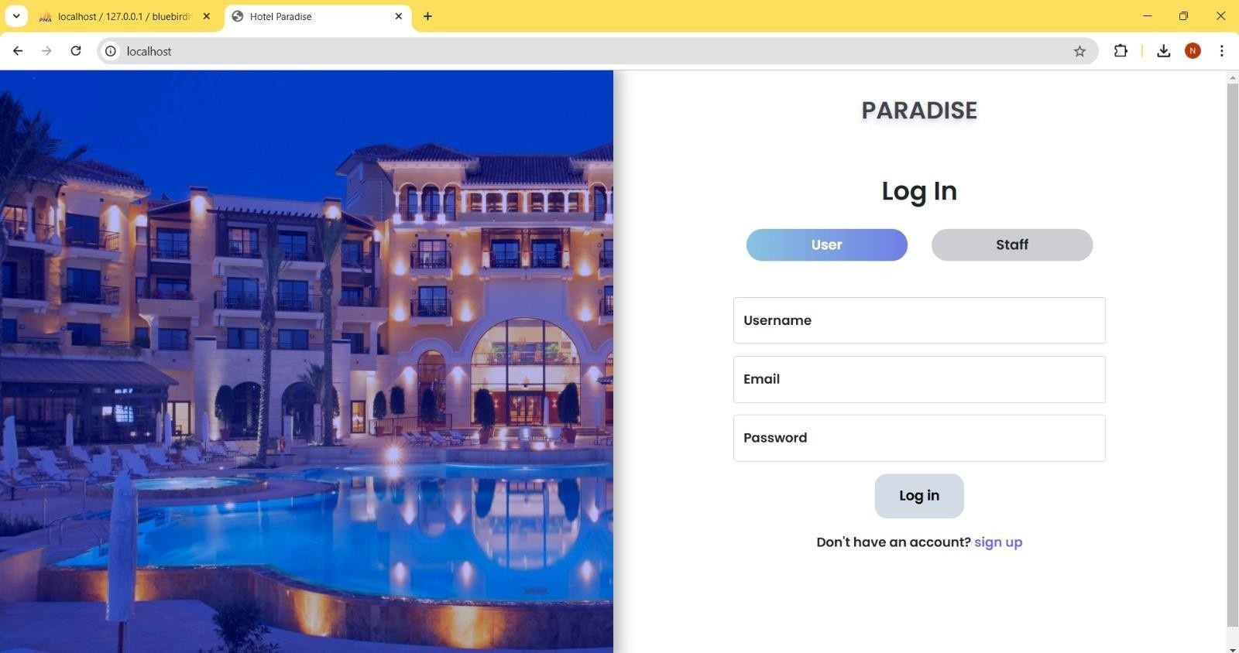

Figure 1: Login Page
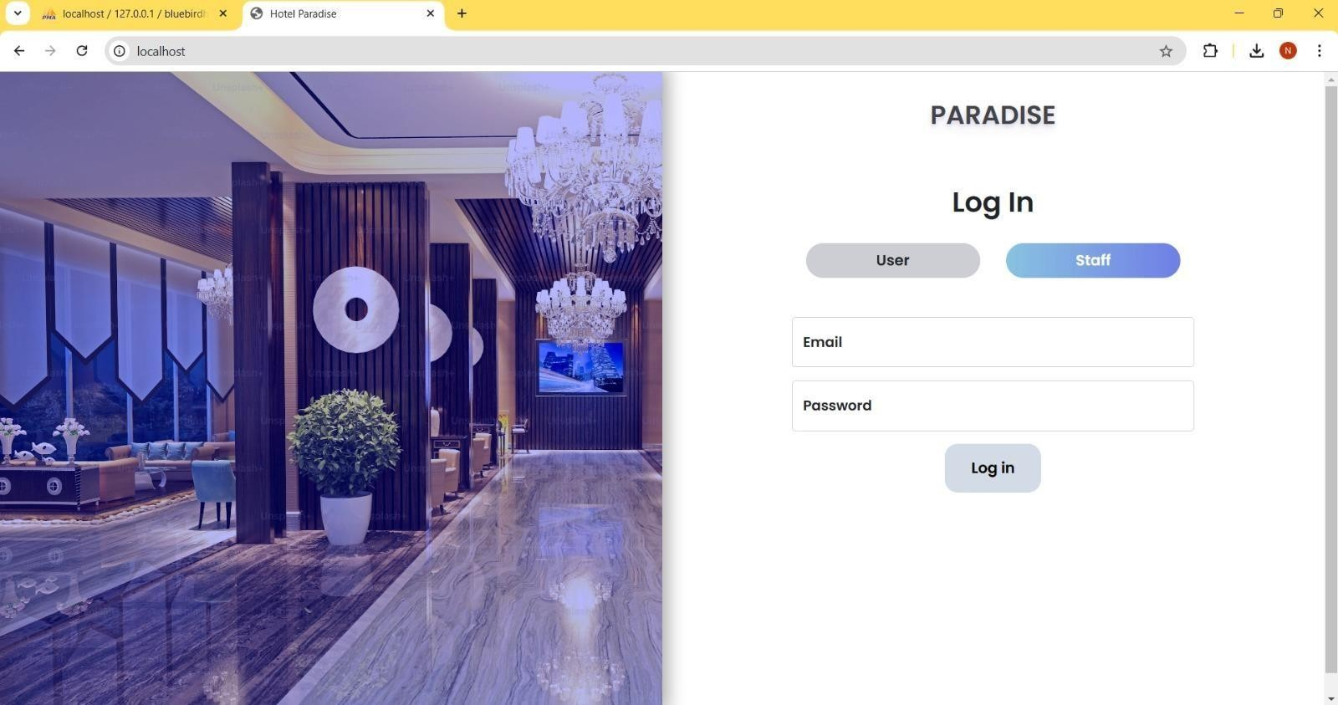

Figure 2: Staff Login
24

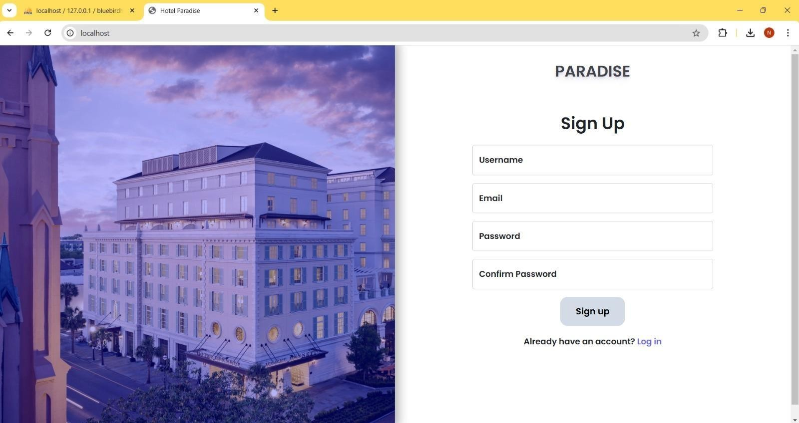

Figure 3: Sign Up Page

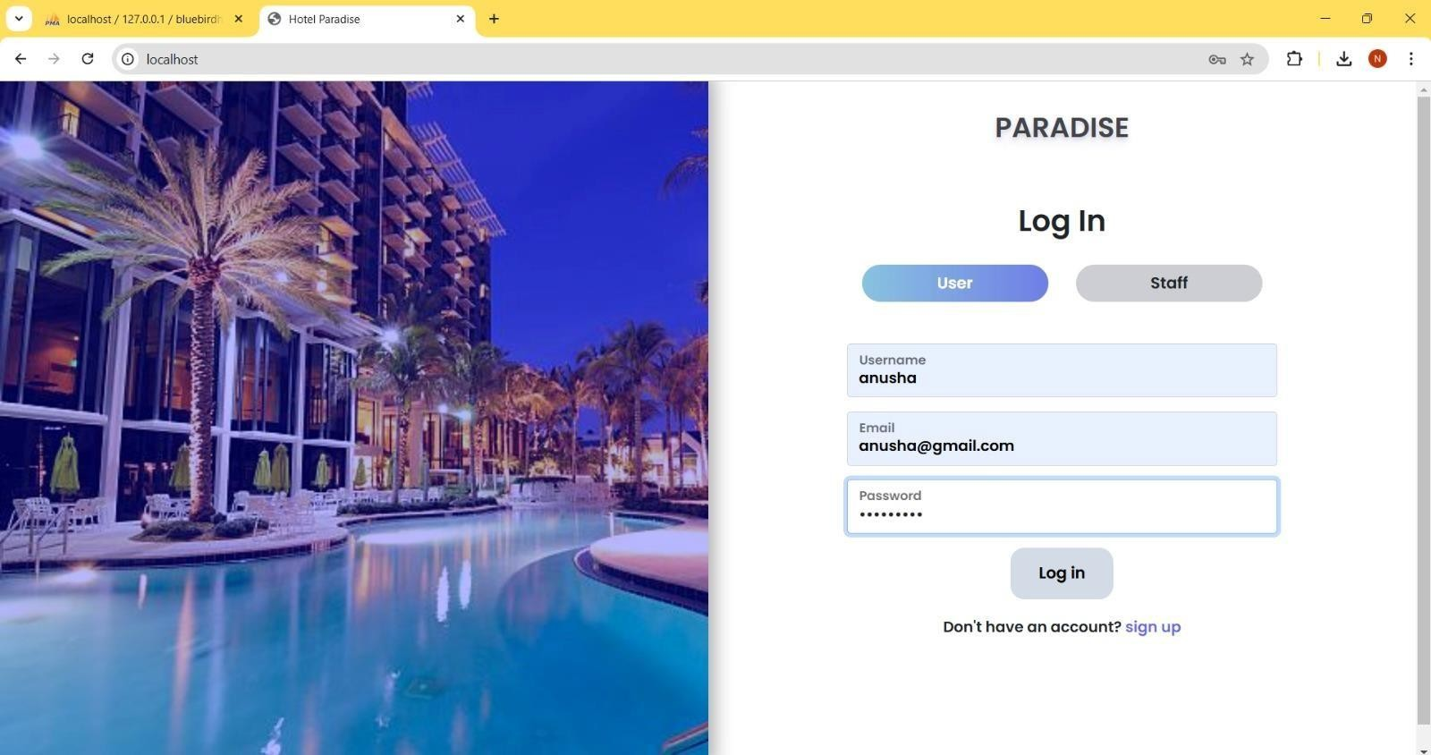

Figure 4: User Login
25

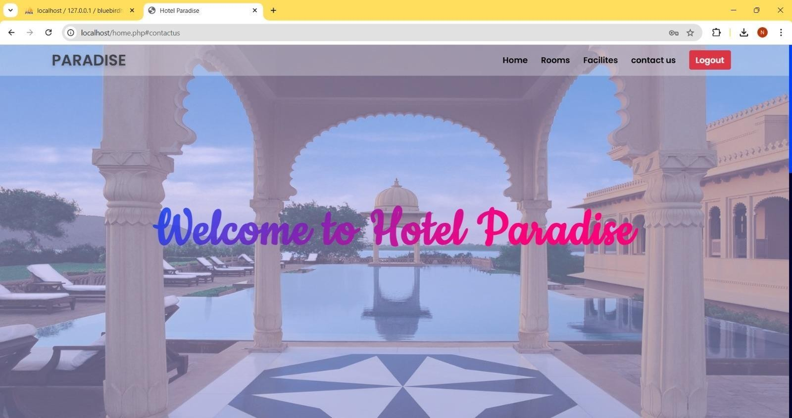

Figure 5: Home Page

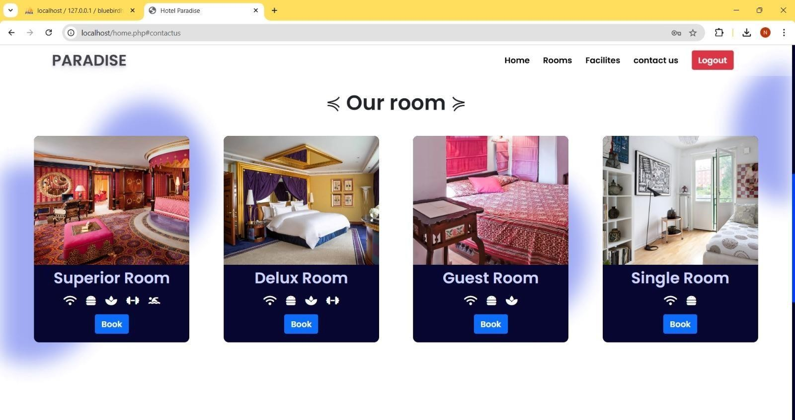

Figure 6: Room Booking Page
26

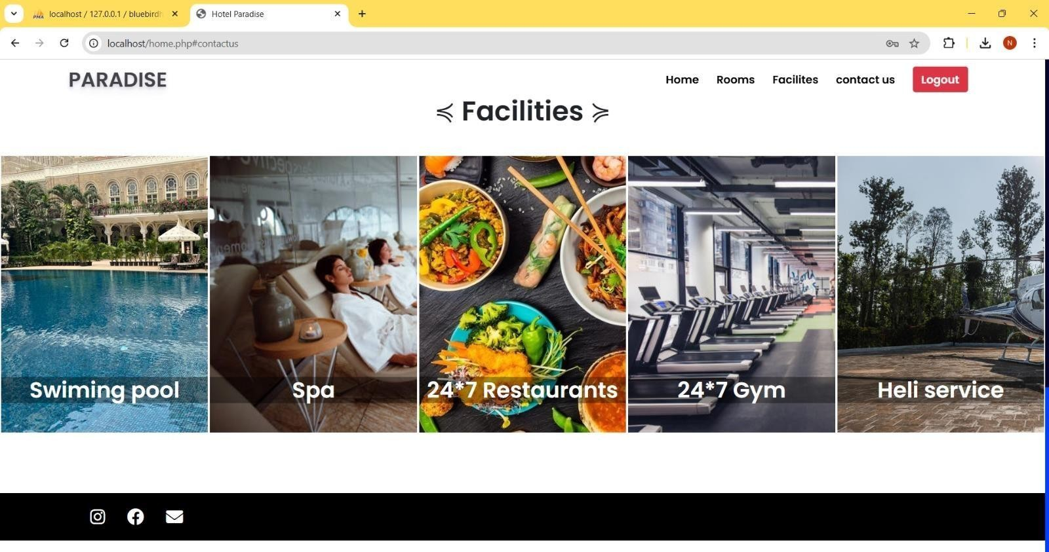

Figure 7: Facilities

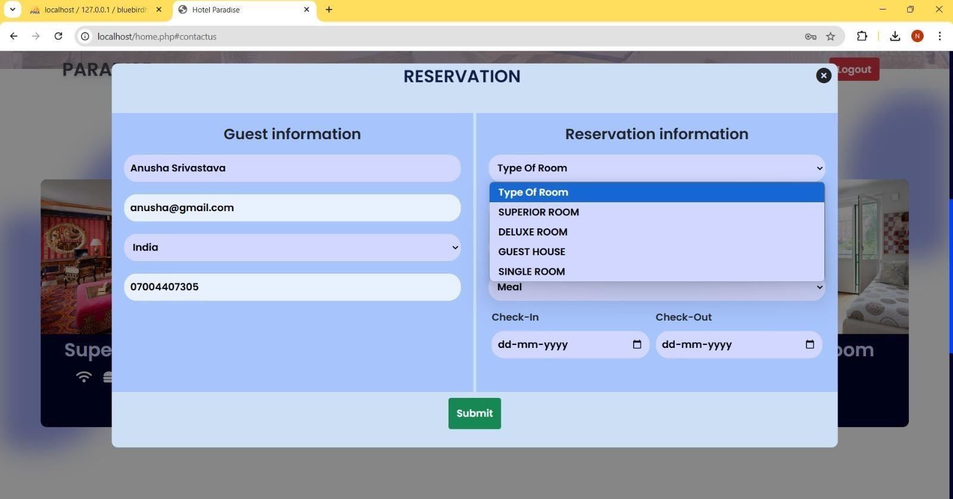

Figure 8: Reservation
27

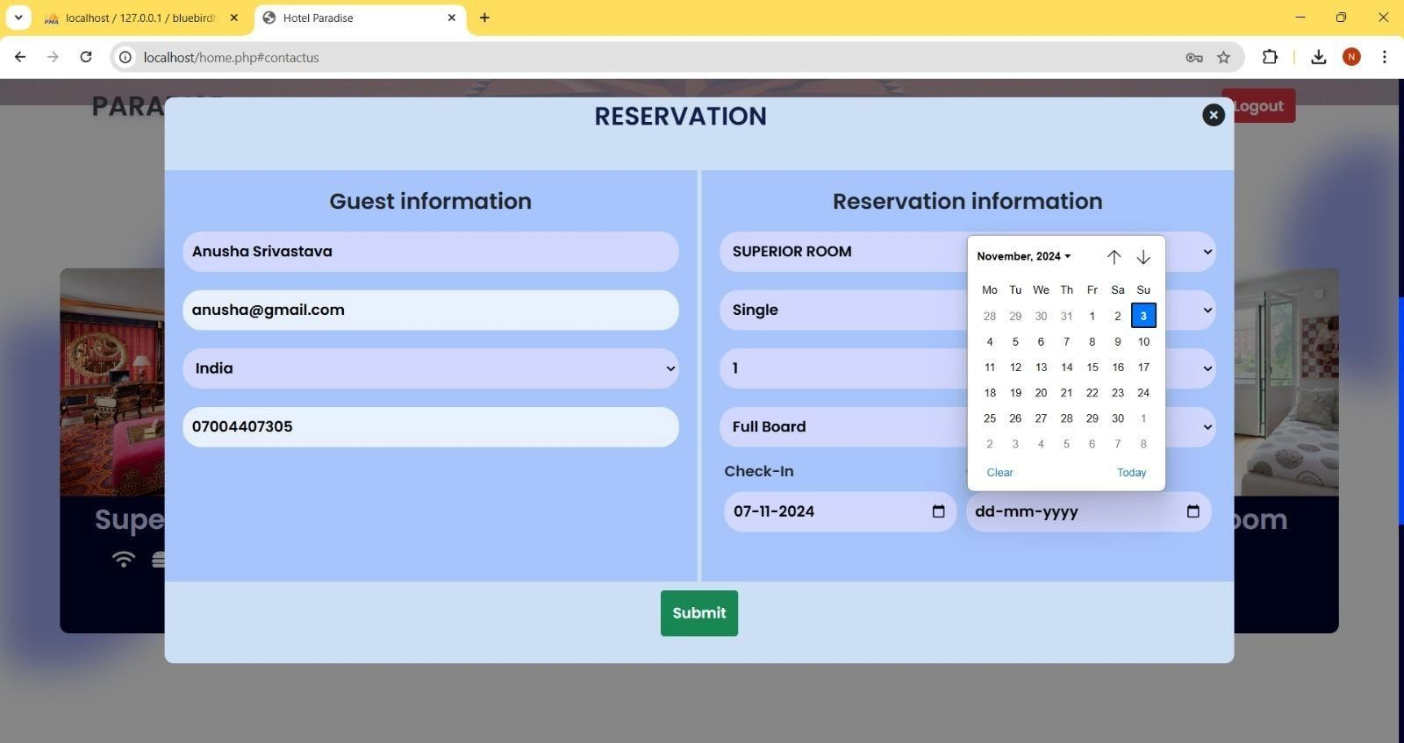

Figure 9: Reservation

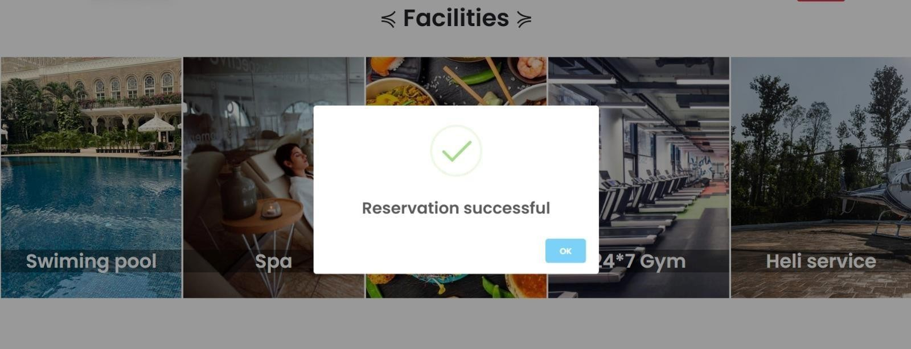

Figure 10: Reservation Successful
28

Conclusion
In conclusion, the Hotel Management System represents a comprehensive solution designed to enhance the efficiency and effectiveness of hotel operations. By integrating modern technologies and frameworks such as React for the frontend and Spring Boot for the backend, the system not only streamlines the booking process but also provides a user-friendly interface for both guests and hotel administrators. The project highlights the importance of developing a cohesive architecture that facilitates seamless interaction between various components, ensuring real-time data synchronization and improved user experiences.

Throughout the development of the Hotel Management System, careful attention was paid to both frontend and backend functionalities. The frontend, built with React, offers an intuitive user interface that simplifies navigation for customers looking to browse services, make reservations, and manage bookings. With features such as a responsive design and easy-to-use components, the system prioritizes user experience, enabling guests to efficiently interact with hotel offerings. The use of Axios for making HTTP requests ensures that the frontend communicates effectively with the backend, providing instant updates and a smooth booking experience.

On the backend, the implementation of Spring Boot alongside MySQL creates a robust and secure environment for managing hotel data. The backend is responsible for processing requests, managing database interactions, and ensuring data integrity. The use of RESTful APIs allows for efficient communication between the frontend and backend, facilitating operations like creating, updating, and retrieving booking information. Security measures, such as authentication and validation, are also embedded within the backend to protect sensitive user data, reinforcing the system's reliability.

Testing and deployment are crucial steps in delivering a stable and functional application. The comprehensive testing strategy includes unit tests, integration tests, and end-to-end tests that verify the system's functionality at various levels. These tests ensure that all components work together as intended and that any potential issues are identified and addressed before deployment. The CI/CD pipeline further automates the deployment process, allowing for continuous updates and improvements, which are essential in today’s rapidly changing technological landscape.

As the Hotel Management System progresses, there are numerous opportunities for future enhancements. Features such as payment gateways, user authentication systems, and real-time notifications can be integrated to provide an even more comprehensive service to users. Additionally, expanding the system to accommodate various types of accommodations and services will broaden its appeal to a wider range of clients. The modular architecture allows for easy scalability, ensuring that the system can adapt to evolving business needs.
29

8.2 Future Scope

The future scope of the Hotel Management System is promising, as the hospitality industry continues to evolve and adapt to changing consumer demands and technological advancements. This project lays a strong foundation for further enhancements and expansions that can significantly improve its functionality and user experience.

One of the key areas for future development is the integration of advanced analytics and business intelligence features. By leveraging data analytics tools, hotel operators can gain valuable insights into customer preferences, booking patterns, and service usage. This data can help in making informed decisions related to marketing strategies, pricing models, and service offerings. For instance, predictive analytics can be utilized to forecast peak booking periods, allowing hotels to optimize their staffing and inventory management accordingly. Additionally, personalized marketing campaigns can be developed based on customer behavior, leading to improved customer satisfaction and loyalty.

Another promising avenue for the future scope of the system is the incorporation of artificial intelligence (AI) and machine learning (ML) technologies. AI can enhance customer interactions through chatbots and virtual assistants that provide instant responses to inquiries, manage bookings, and offer personalized recommendations. Machine learning algorithms can analyze customer data to identify trends and suggest tailored experiences, thereby increasing engagement and enhancing guest satisfaction. This shift toward AI-driven services aligns with the growing demand for personalized and efficient customer experiences in the hospitality sector.

Furthermore, expanding the system to support mobile applications can significantly enhance user engagement and accessibility. As more consumers prefer to use their smartphones for travel planning and booking, developing a mobile app can provide an on-the-go solution for customers to manage their reservations, access hotel information, and receive real-time notifications. A mobile platform can also facilitate contactless services, which have become increasingly important in response to health concerns and changing consumer preferences.

The integration of online payment systems is another critical area for enhancement. By implementing secure payment gateways and multiple payment options, including digital wallets and cryptocurrencies, the system can cater to a broader range of customers. Ensuring that the payment process is seamless and secure is paramount, as it can directly impact customer trust and satisfaction. Additionally, features such as automated billing, invoicing, and payment tracking can streamline financial operations for hotel administrators.
30

References
- K. L. J. C. M. Kumar, "Spring in Action," Manning Publications, 2018.
- H. M. K. R. S. S. Marzi, "Pro React 16," Apress, 2018.
- R. J. M. A. C. E. E. Garcia, "Learning JavaScript Data Structures and Algorithms," Packt Publishing, 2016.
- Online Resources:
  - Spring Boot Documentation:
[https://docs.spring.io/spring-boot/docs/current/reference/htmlsingle/](https://docs.spring.io/spring- boot/docs/current/reference/htmlsingle/)
  - React Documentation:
[https://reactjs.org/docs/getting-started.html](https://reactjs.org/docs/getting-started.html)
  - MySQL Documentation: [https://dev.mysql.com/doc/](https://dev.mysql.com/doc/)
  - 3. Research Papers:
  - A. J. Abdu, "A Comprehensive Study on Hotel Management Systems," International Journal of Computer Applications, vol. 178, no. 33, pp. 18-22, 2019.
  - D. Sharma, A. Sharma, "Cloud-Based Hotel Management System: A Review," Journal of Theoretical and Applied Information Technology, vol. 95, no. 14, pp. 3460-3470, 2017.

- Web Articles:
  - "How to Build a Hotel Management System Using React and Spring Boot," Medium, [https://medium.com/@author/how-to-build-a-hotel-management-system-using-react-and-spring-boot- 123456789](https://medium.com/@author/how-to-build-a-hotel-management-system-using-react-and-spring- boot-123456789).
  - "Understanding the Basics of a Hotel Management System," Journal of Hospitality and Tourism Technology, [https://www.emerald.com/insight/content/doi/10.1108/JHTT-04-2019- 0071/full/html](https://www.emerald.com/insight/content/doi/10.1108/JHTT-04-2019-0071/full/html).

- GitHub Repositories:
- "Spring Boot Hotel Management System," GitHub,
[https://github.com/username/hotel-management-system](https://github.com/username/hotel-management- system)
- "React Hotel Booking Application," GitHub,
[https://github.com/username/react-hotel-booking](https://github.com/username/react-hotel-booking)
31

APPENDIX 1 CODE:

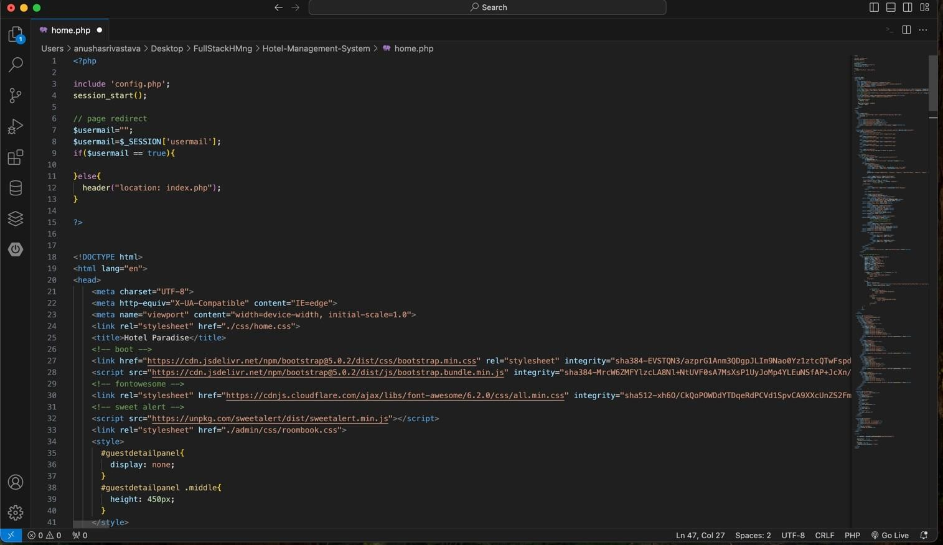


32

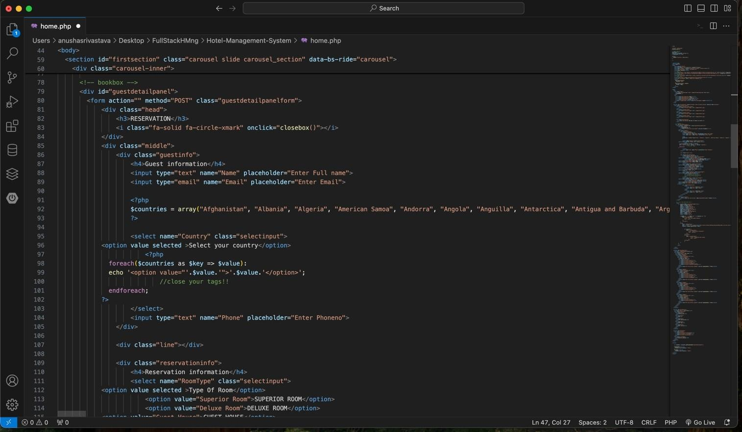

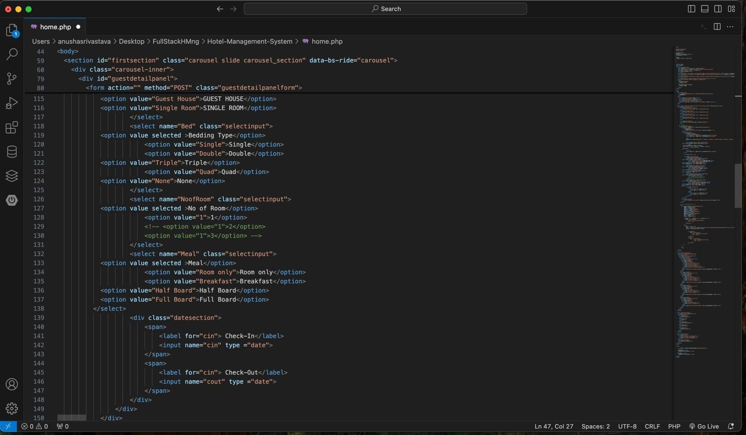
33

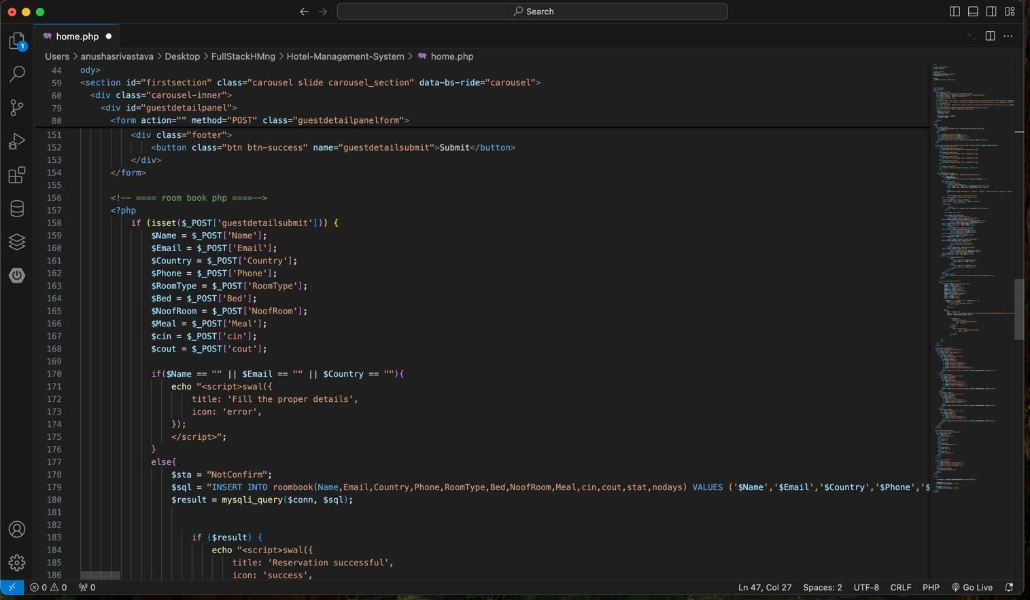

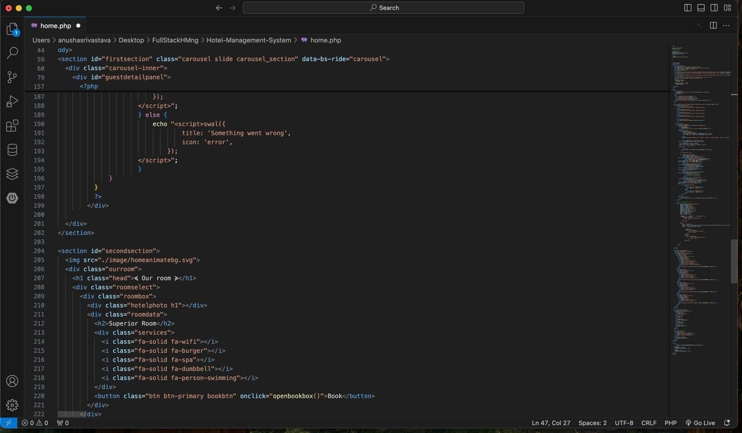
34

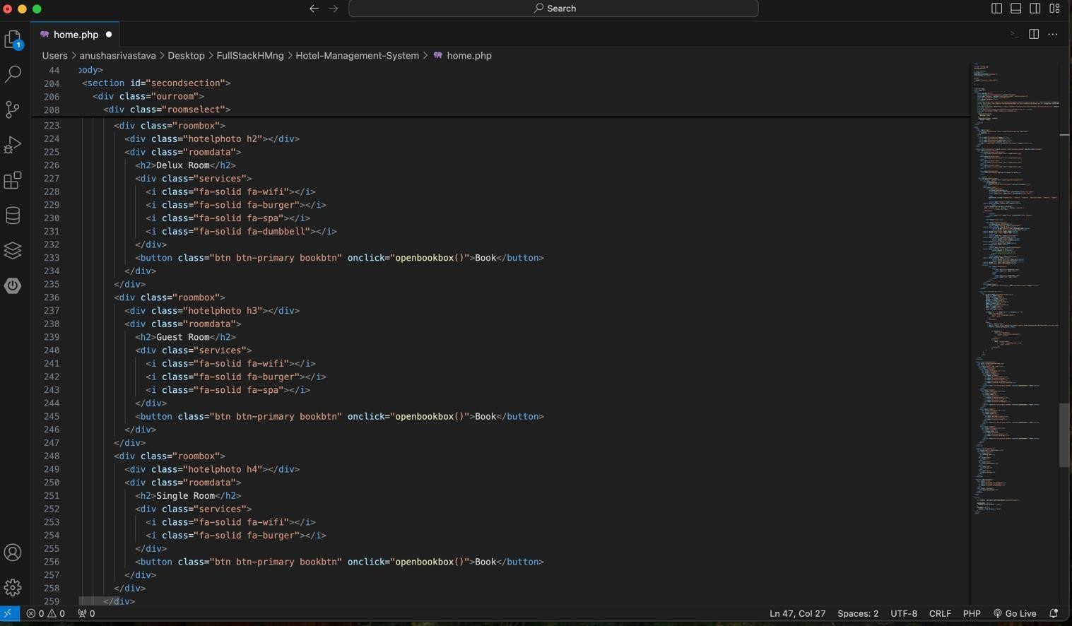

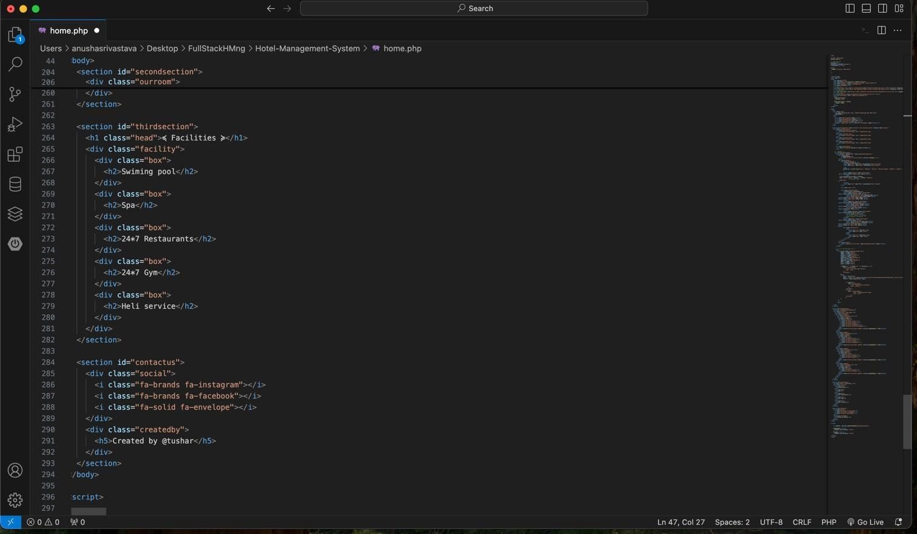
35

